影像處理 Homework 4

資工112 40847015S 紀軒宇

* Statement

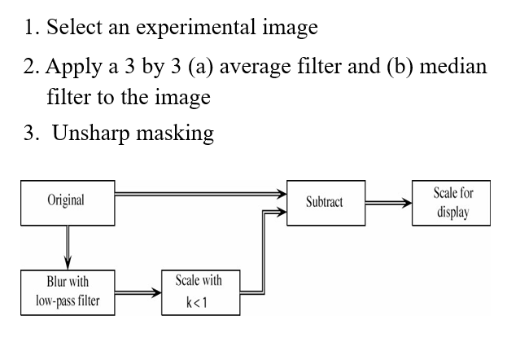

* Code
* import cv2
* import numpy as np
* img = cv2.imread("cat.jpg")
* kernel_size = 3
* k = 0.9
* img_avg = cv2.blur(img, (kernel_size, kernel_size))
* img_avg = img-img_avg*k
* img_avg = np.clip((img_avg /(1-k)), 0, 255).astype('uint8')
* showdata = np.hstack([img, img_avg])
* cv2.imshow(str(k)+"avg.jpg", showdata)
* cv2.waitKey(0)
* img_med = cv2.medianBlur(img, kernel_size)
* img_med = img - img_med*k
* img_med = np.clip((img_med /(1-k)), 0, 255).astype('uint8')
* showdata = np.hstack([img, img_med])
* cv2.imshow(str(k)+"med.jpg", showdata)
* cv2.waitKey(0)
* 輸入/輸出圖片

k=0.9

average filter

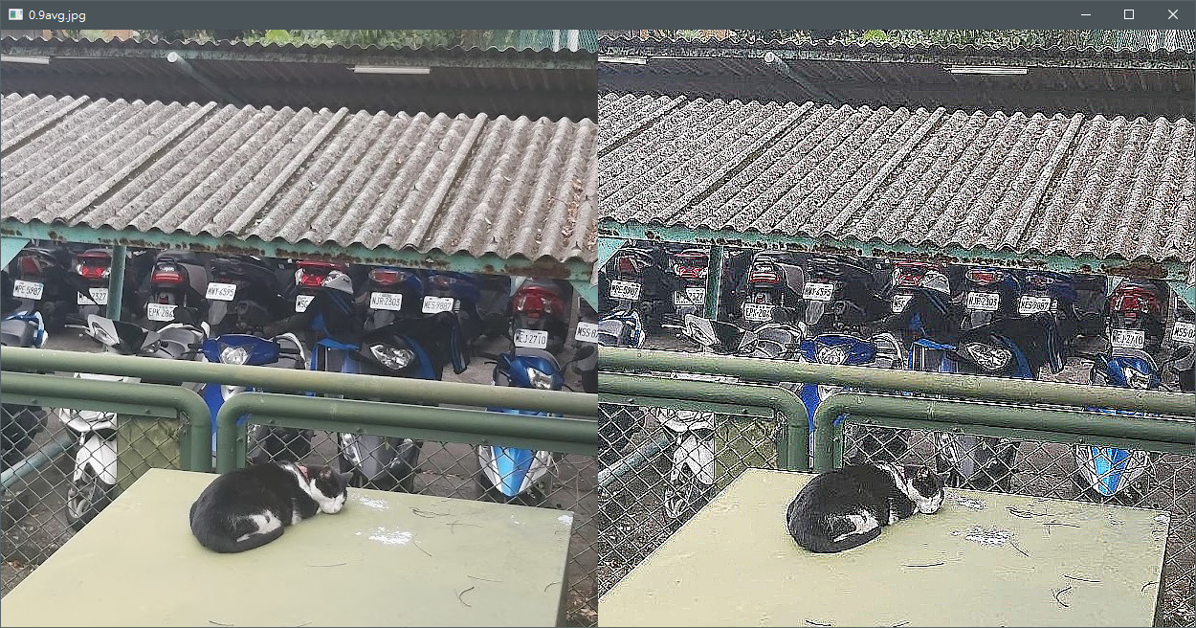

median filter

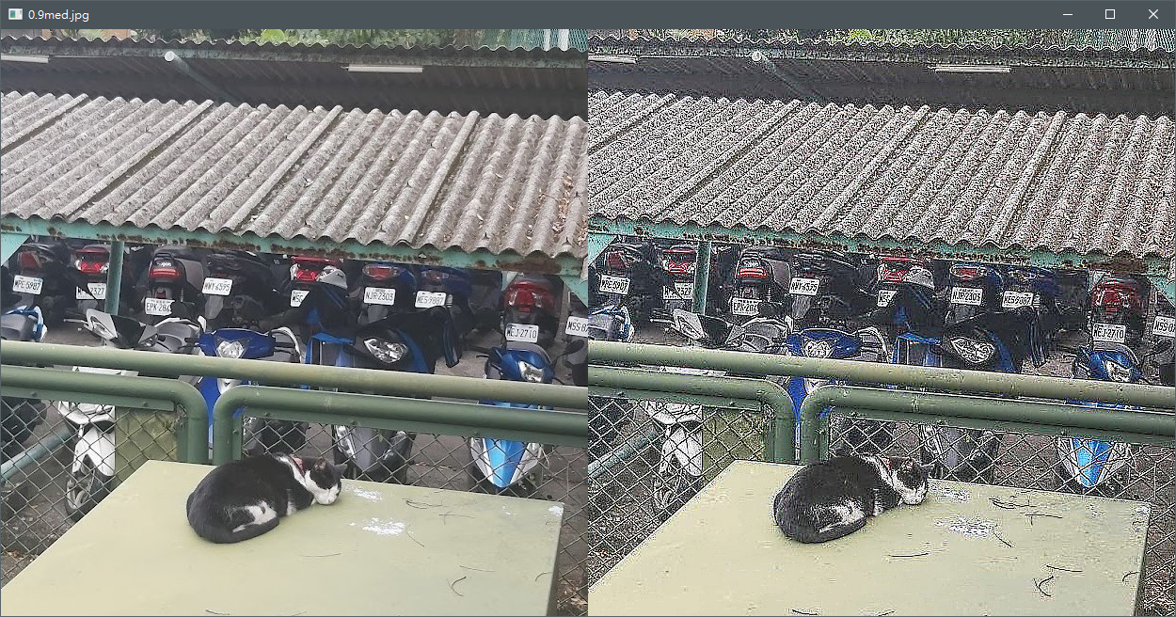

k=0.5

average filter

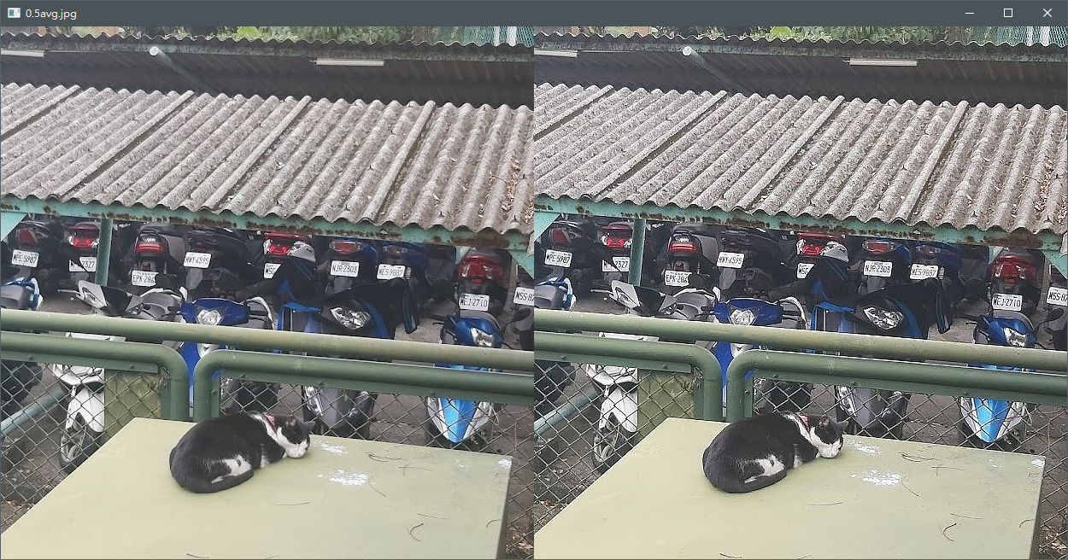

median filter

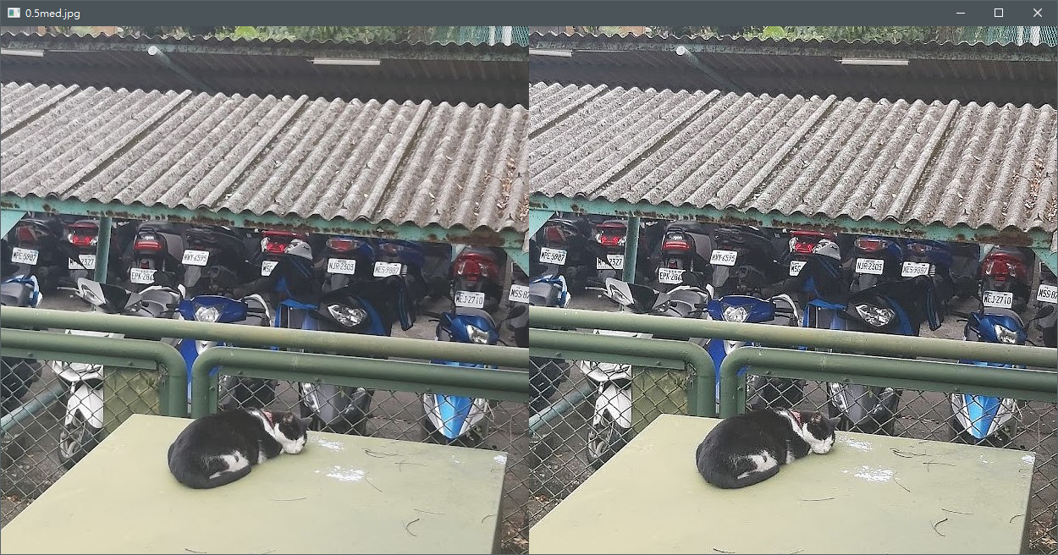

* 心得

從這些實驗結果可以看出 k 的值就是其Unsharp masking 的程度係數，filter部分，比較average filter（左）與median filter（右）的比較起來 average filter的邊有較多鋸齒狀的現象

